**DAKSH PATEL**

**STUDENT ID:- L39141411**

**BLOCK :- 6**

**BACK-END DEVELOPMENT**

**Table of Contents**

1.Introduction 3

1.1 Aim and Objective 3

1.2 Background Study 3

2. Part 1 4

3. Part 2 8

4. Conclusion 15

Reference list 17

# 1.Introduction

A vital component of creating a website that performs data entry into a database is back-end software development. The back end is in charge of managing the server-side components of the application, including data processing and database communication. Developers must complete several procedures in order to create a website from scratch that performs data entry into a database. A thorough understanding of back-end software development fundamentals, such as database architecture, programming languages, server configuration, and testing/debugging, is necessary when creating a website from scratch to execute data entry into a database. Web developers may construct dependable, salable apps that can scale to meet the needs of a variety of users by using the proper methodology and paying close attention to the details. By creating a website from scratch and performing data input into a database, this program provides students with an introduction to back-end software development. An Entity Relationship diagram will need to be implemented from a given set of requirements after being given a basis in RDBMS design. The next step is to create a database from a provided schema.

## 1.1 Aim and Objective

**Aim:**

The aim of this research study is to develop a web based School management  system of Rishtan Academy Primary School which will be RDBMS based that can store all of these records of the primary school electronically.

**Objective:**

* To build an ER diagram for the database that holds the necessary information of the school.
* To create a web-based school management system to store and manage school operations.
* To establish effective and dynamic implementation of PHP, HTML, CSS and MySQL.

## 1.2 Background Study

In this study, the researcher takes on a new role as a back-end web developer for a small company known as “Rishton Academy Primary School”. In order to store data about students, parents, teachers, classes, etc., the school now uses paper-based records. Ahead of the teacher has hired to develop a web-based digital system with a relational database to store all of these records digitally. A solution can be designed and implemented using the PHP programming language and a compatible database; to do this, competency in PHP can be developed throughout the course of this semester. The ability to set up a web server using Linux is regarded as a crucial talent in the business world, and it is compulsory for students of the BSc (Hons) Computer Science course.

# 2. Part 1

The researcher has to determine the entities and relationships involved in order to design an ER diagram for a database that can house the data needed by the school. Some of the entities that may be added, based on the conditions given, are ***Class, Pupils, parents/guardian, Teachers***. The researcher must determine the attributes (columns) and data types for each entity as well as the “primary keys (PK)” and “foreign keys (FK)” that connect the entities. The researcher must also establish the cardinality, that is, whether the relationships are “one-to-one”, “one-to-many”, or “many-to-many” of the relationships between the entities(Deshpande *et al.* 2021).

The ER diagram is designed based on the information given:

***Classes:***

ClassID (PK, int)

ClassName (varchar)

ClassCapacity (int)

TeacherID (FK, int)

***Pupils:***

PupilID (PK, int)

PupilName (varchar)

PupilAddress (varchar)

MedicalInformation (varchar)

ClassID (FK, int)

***Parents/Guardians:***

ParentID (PK, int)

ParentName (varchar)

ParentAddress (varchar)

ParentEmail (varchar)

ParentPhone (varchar)

***PupilParents:***

ParentsID (FK, int)

PupilID (FK, int)

***Teachers:***

TeacherID (PK, int)

TeacherName (varchar)

TeacherAddress (varchar)

TeacherPhone(varchar)

TeacherSalary(varchar)

TeacherImage(text)

TeacherDoc(text)

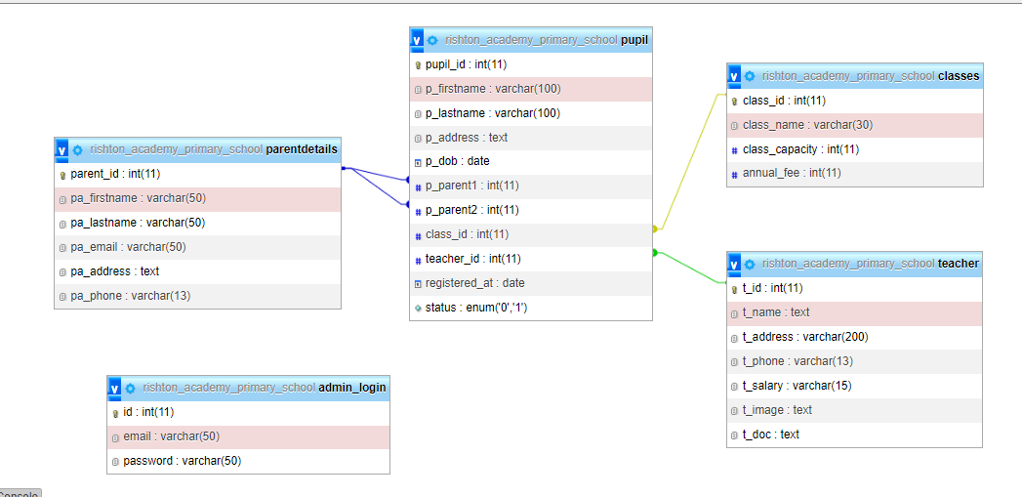

**Figure 1: ERD diagram**

(Source: Created by the learner)

The above image shows the ERD diagram of the entire system. This diagram have several entity with some of the columns. For every entity the researcher set the primary key and foreign key separately (Negozio *et al.*2020).

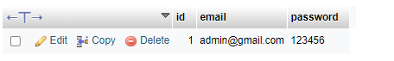

**Figure 2: Admin_login**

(Source: Created in PHPmyadmin)

This is the "Admin_login" table which includes some of the basic columns such as "I'd","email" and "password".

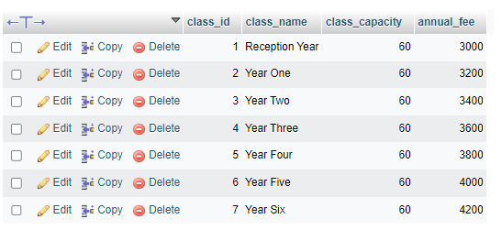

**Figure 3: Class table**

(Source: Created in PHPmyadmin)

Here are the class table of the database system. With the help of the above image easily understand the entire column of the class table.

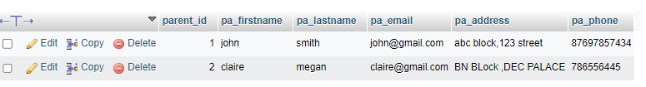

**Figure 4: Parent Details Table**

(Source: Created in PHPmyadmin)

The Parentdetails table includes some of the columns such as parent_id, pa_firstname etc.



**Figure 5: Pupil Table**

(Source: Created in PHPmyadmin)

Here, the researcher creates the “pupil table” that includes ten column such as pupil_id, p_firstname, p_lastname, p_address, p-dob, p_parent1, p_parent2, class_id, teacher_id and register_at.

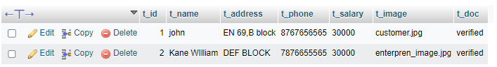

**Figure 6: Teacher Table**

(Source: Created in PHPmyadmin)

Here, the researcher created the “teacher table” that includes 7 columns such as t_id, t_name, t_address, t_phone, t_salary, t_image and t_doc.

# 3. Part 2

**Admin login**

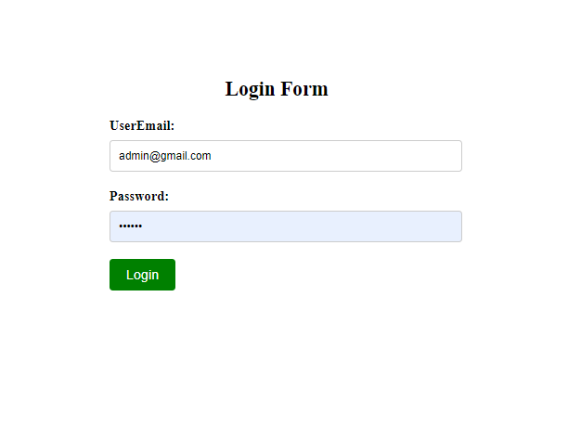

**Figure 7: Login Form**

(Source: Created by the learner)

This is the login form which helps the user to login in the portal with the help of the login credential.

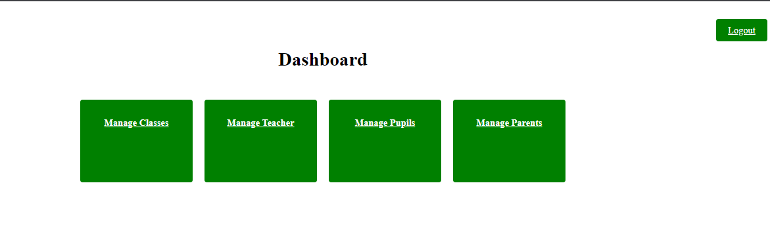

**Figure 8: Dashboard**

(Source: Created by the learner)

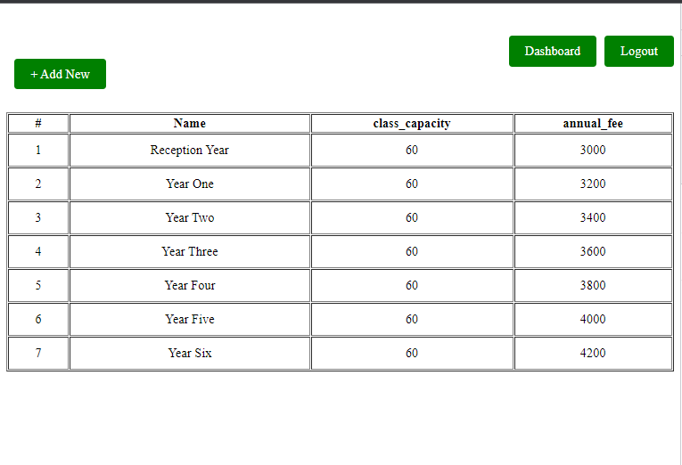

**Figure 9: Class list view page**

(Source: Created by the learner)

The review page shows the lists of the school on a yearly basis. Some of the basic features which are available in the review page such as name, class_capacity and annual_fees.

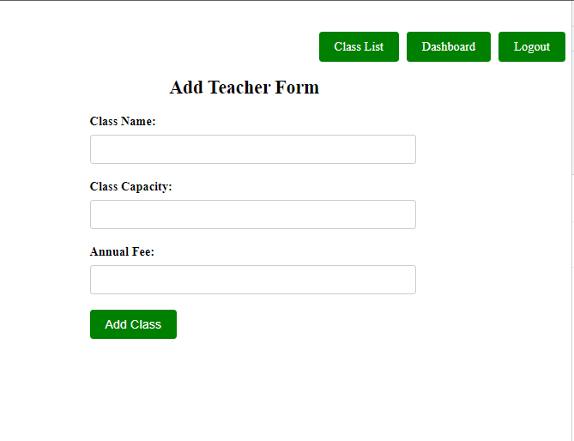

**Figure 10: Teacher Form**

(Source: Created by the learner)

Teacher form helps to store the details in a single location.

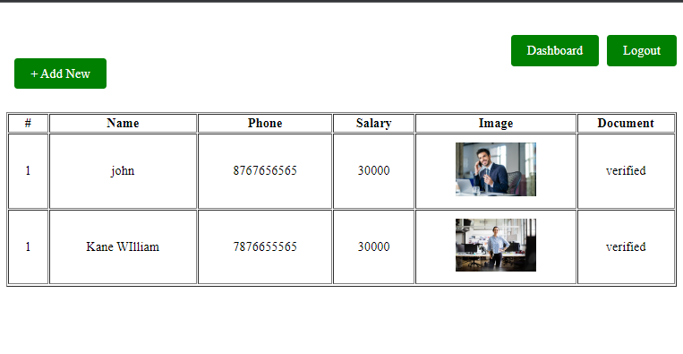

**Figure 11: Teacher list**

**(**Source: Created by the learner)

The teacher list page helps to acknowledge the available teacher. Also, this page shows some of the details of the teacher such as name, phone, Salary, Image and document. With the help of the " Add" button researcher able to add new teacher details within the database system (Li *et al.*2020)**.**

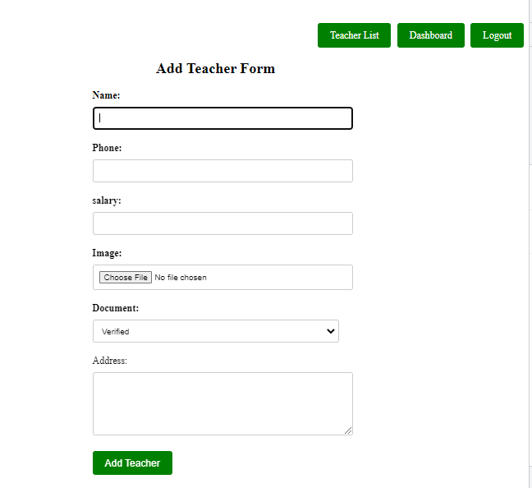

**Figure 12: Add new teacher**

**(**Source: Created by the learner)

The researcher created a new teacher page to store all the details.

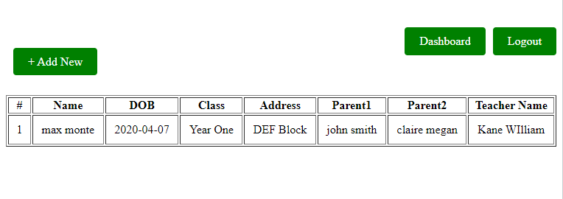

**Figure 13: Pupil list**

**(**Source: Created by the learner)

Here, the researcher creates the list of pupil.

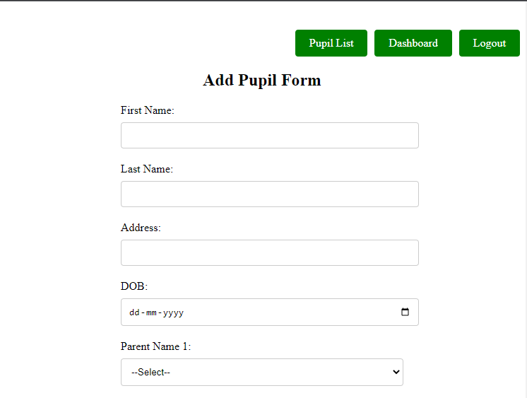

**Figure 14: Add new Pupil**

**(**Source: Created by the learner)

Here, the researcher creates the page for add new pupil.

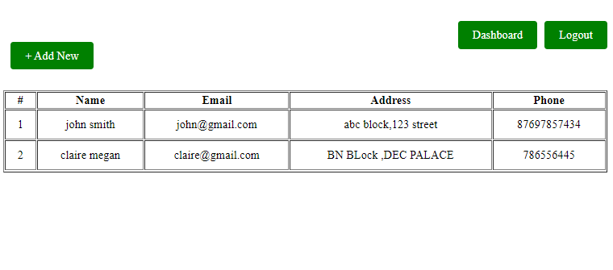

**Figure 15: Parent list**

**(**Source: Created by the learner)

Here, the researcher creates the list of parents.

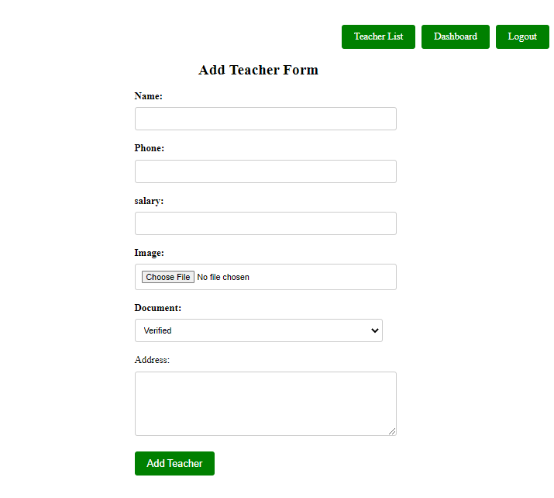

**Figure 16: Add parents page**

**(**Source: Created by the learner)

The parent page has some options such as name, image, phone, salary etc.

# 4. Conclusion

To conclude, the implementation and report has helped the students learn back-end software development in this module by creating a website from scratch and entering data into a database. An Entity Relationship diagram needs to be implemented from a given set of requirements after receiving a foundation in RDBMS design. For creating and implementing a solution, the PHP programming language and a suitable database must be used. The aim of this research study is properly fulfilled by the researcher by creating the ERD along with the tables. The database is created with the help of PHPmyadmin that holds all the records of the school digitally.

# Reference list

Deshpande, V., Nair, K.S., Holzer, M., Banerjee, S. and Dubourdieu, C., 2021. CMOS back-end-of-line compatible ferroelectric tunnel junction devices. *Solid-State Electronics*, *186*, p.108054.

Li, Y.Z., Gao, S., Pan, J., Guo, B.F. and Xie, P.F., 2020. Research and application of template engine for web back-end based on MyBatis-Plus. *Procedia Computer Science*, *166*, pp.206-212.

Malikova, Z. and Kaarov, Y., 2022. Front-end & Back-end: Differences and Development Features. *Bulletin of Science and Practice*.

Negozio, M., Pelaccia, R., Donati, L., Reggiani, B., Tomesani, L. and Pinter, T., 2020. FEM Validation of front end and back end defects evolution in AA6063 and AA6082 aluminum alloys profiles. *Procedia Manufacturing*, *47*, pp.202-208.

Pham, A.D., 2020. Developing back-end of a web application with NestJS framework: Case: Integrify Oy’s student management system.